
North Bengal International University

Lab Report: 01

Exp Name : Subtraction of two Binary number using 1’s complement.

Subject : Computer Architecture & Organization Seassional
Subject Code : CSE 0612-3142

Submitted By:
Name : Md. Tanvir Rahman Pranto
Dept : CSE
Roll : 0712340012101005
Semester : 2nd Year, 4th semester.

Submitted To:
Name : Md. Shafiuzzaman
Designation : Lecturer
Dept : CSE
Date :

Experiment No: 01
Experiment Name: Subtraction of two Binary number using 1’s Complement.
Theory: In binary subtraction using 1's complement, you first convert the number you want to subtract into its 1's complement by flipping its bits (0s become 1s and 1s become 0s). Next, you add this modified number to the number you are subtracting from. If there is an extra bit (a carry), add it to the result. This method helps computers perform subtraction easily and efficiently.
Here shown the subtraction (1010)₂ from (1000)₂ using 1’s complement method.
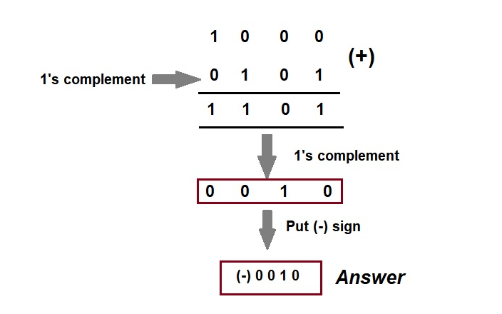

Here shown the subtraction (1010)₂ from (1111)₂ using 1’s complement method.
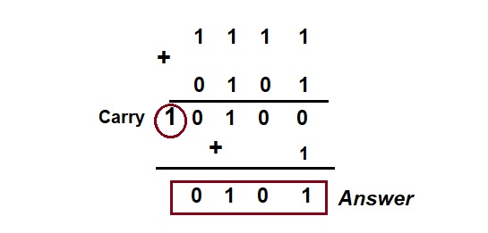
Code:
#include <stdio.h>

int main() {
int A[5], B[5], Sum[6];
int carry = 0;

// Input values for A
printf("Enter 5-bit binary number A: ");
for (int i = 0; i < 5; i++) {
scanf("%d", &A[i]);
}

// Input values for B
printf("Enter 5-bit binary number B: ");
for (int i = 0; i < 5; i++) {
scanf("%d", &B[i]);
}

// Compute 1's complement of B
for (int i = 0; i < 5; i++) {
B[i] = 1 - B[i];
}

printf("\n1's Complement of B: ");
for (int i = 0; i < 5; i++) {
printf("%d", B[i]);
}
printf("\n");

// Perform binary addition (A + 1's complement of B)
for (int i = 4; i >= 0; i--) {
int sumBit = A[i] + B[i] + carry;
Sum[i + 1] = sumBit % 2; // Store binary sum
carry = sumBit / 2; // Compute carry
}
Sum[0] = carry; // Store the final carry

// Display the sum result
printf("\nSum: ");
for (int i = 0; i < 6; i++) {
printf("%d", Sum[i]);
}
printf("\n");

// Display final carry
printf("Carry: %d\n", carry);

return 0;
}
Output:
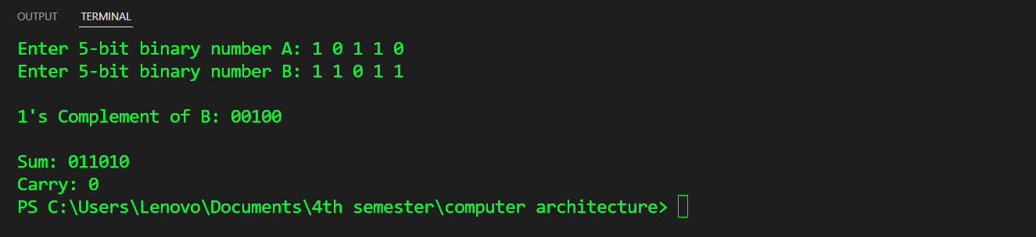

Conclusion: Conclusion: This program demonstrates binary addition using 1’s complement. It takes two 5-bit binary numbers as input, computes the 1’s complement of the second number, and then adds it to the first number. The result is displayed along with the final carry. This method is useful for performing binary subtraction by adding the 1’s complement of a number, making it a fundamental concept in digital arithmetic and computer architecture.

